Functionality:

The screen shall be used to select a value for the Global Parameter.

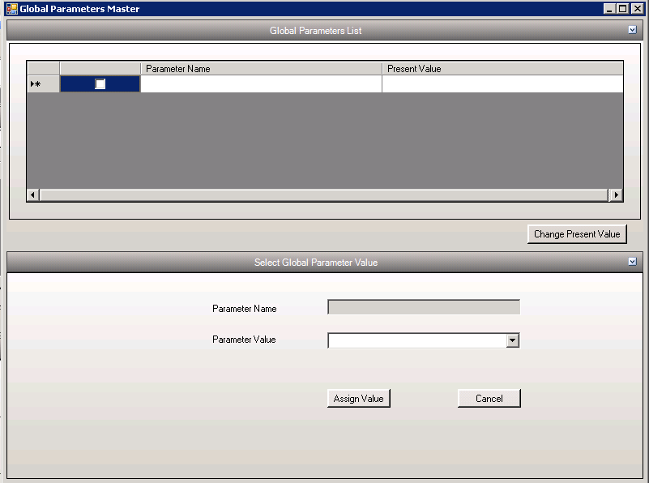

Selecting the Parameter Value
- From the Global Parameters list the corresponding parameter can be selected
- On click of “Change Present Value” the options will open.
- Select the Parameter Value from the given list.
- Change value by clicking “Assign Value” button.

Tables affected:
- GlobalParameterMaster

